LOG DATA CAN MESSAGE EXTRACTOR

This application will take a Kvaser log file that has been extracted to .csv format and condense it into a text file that is playable on Kvaser’s CAN King. It is useful for offline development of Sauer Danfoss display software. It is important to NEVER run extracted files thru CAN King on a live CAN network as it could cause damage to the machinery.

These instructions assume the user is proficient in the use of Kvaser Memorator software.

1. Choose the log data file that you wish to work with from the Kvaser Memorator Tools application.

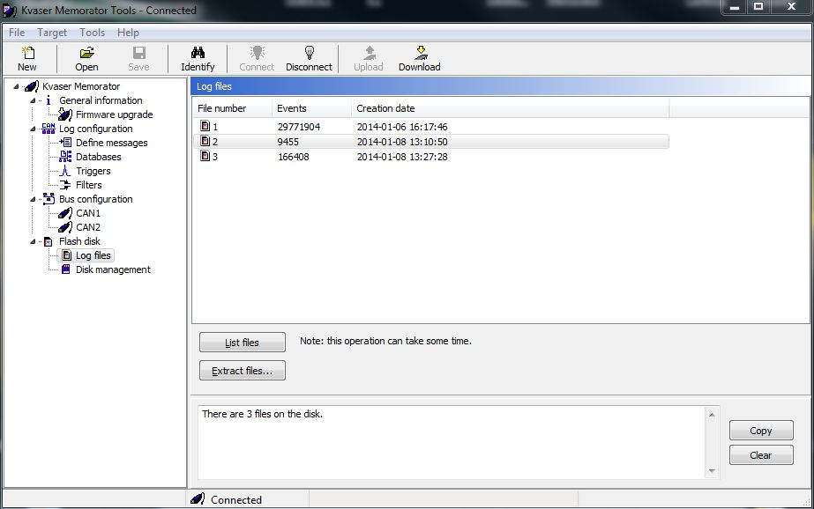

1. Choose “next” and choose the following settings. This will save the data in comma separated value format.

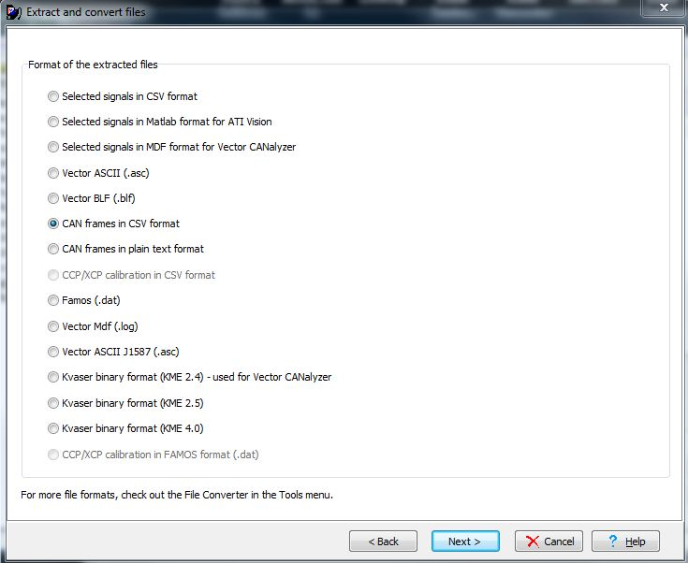

1. Select “next” again and choose the following settings. This will save the data in decimal format.

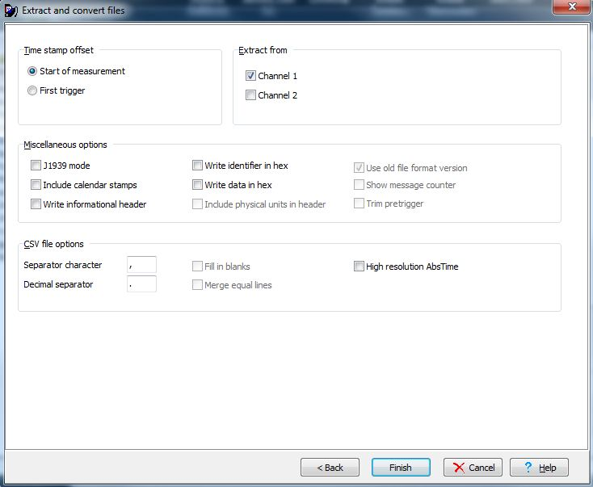

1. Now open the LOG DATA CAN MESSAGE EXTRACTOR application. The window will look like this:

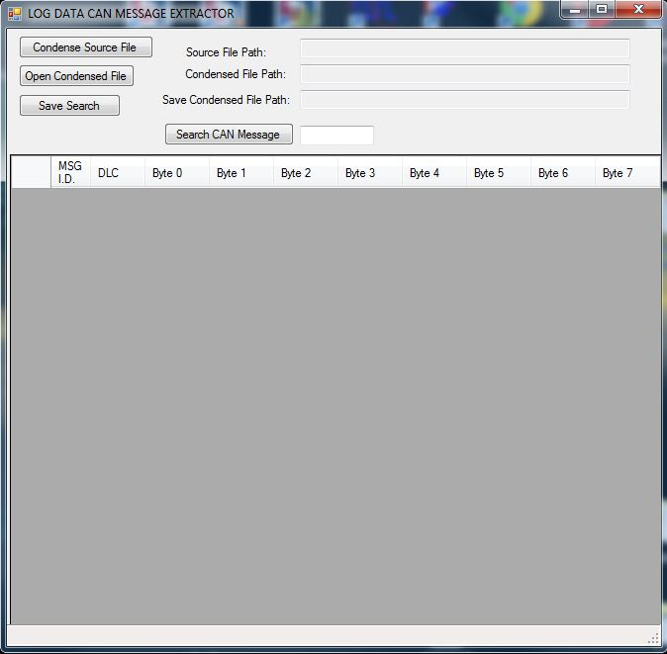

1. Press the “Condense Source File” button and the application will request a path to the source .csv file.

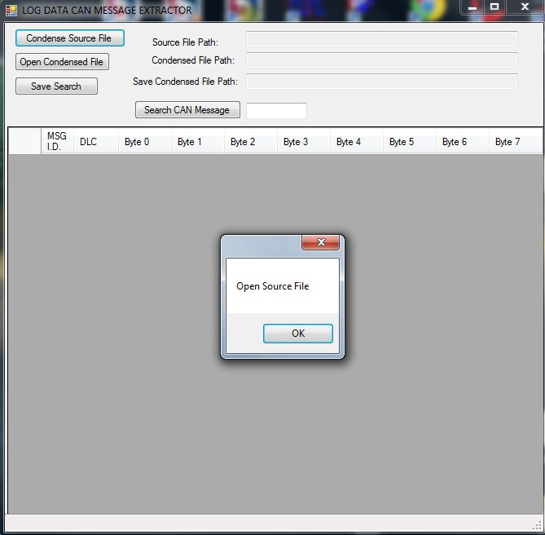

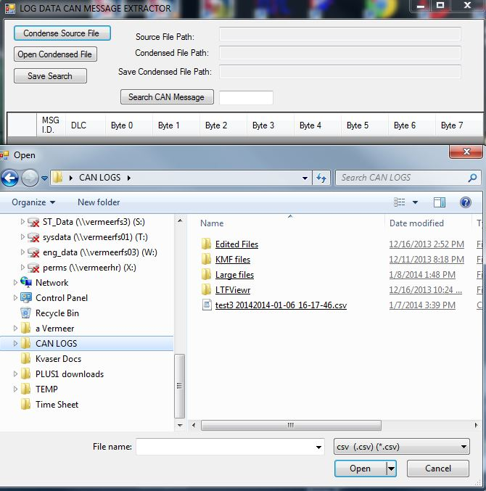

1. Now the application will request a name for the new condensed file which will have an extension of “xxxx.con”.

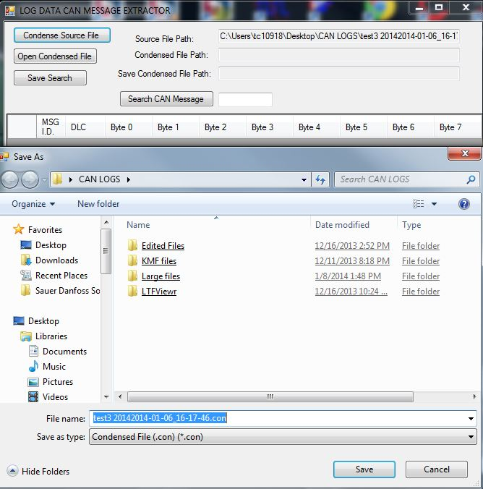

1. The application will now begin condensing the “.csv” file into a form that can be searched. The status bar at the bottom of the screen displays the condensation progress.

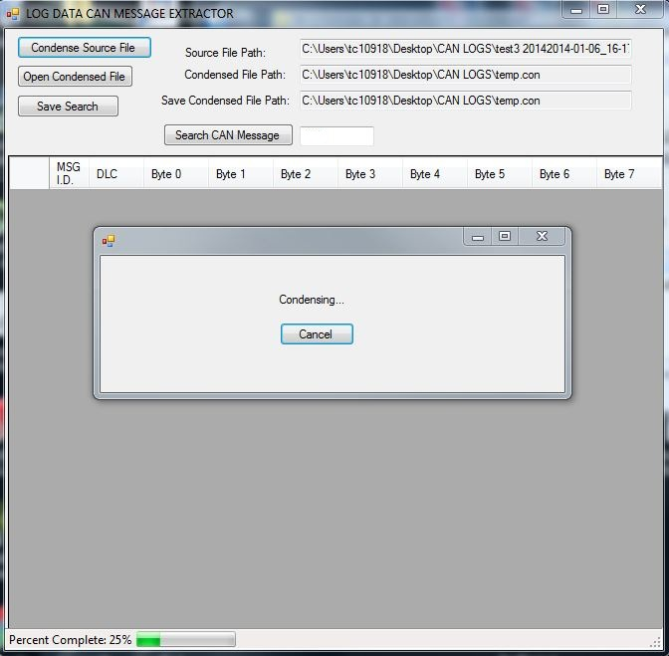

1. Click “OK” to begin working with the condensed file.

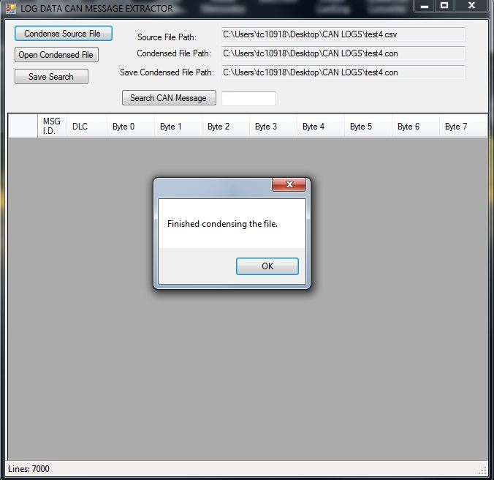

1. Place a CAN message ID number into the search box. In this case the message ID is 100.

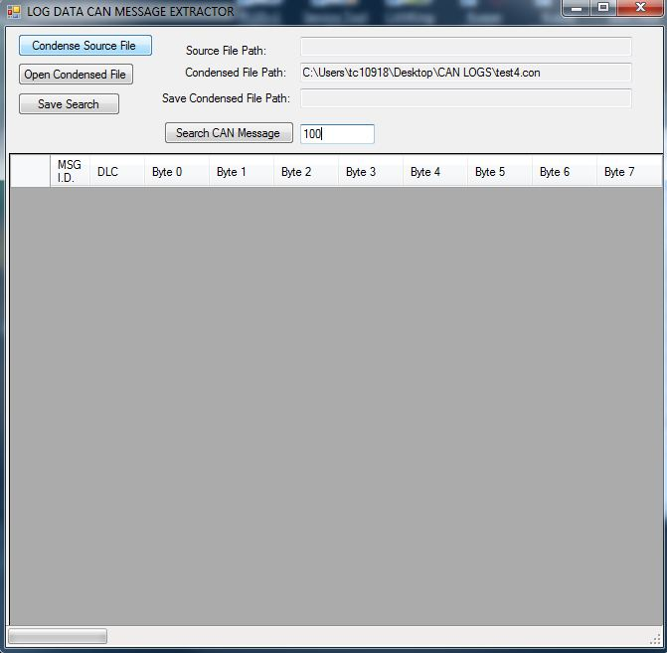

1. A listing of all instances of the desired message will be displayed. In this case the message ID is 100.

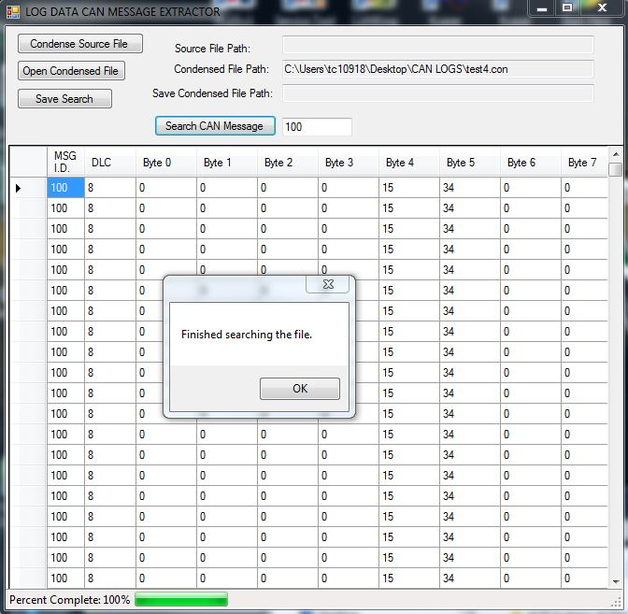

You will now have the option to save the searched data to a “xxxx.hst” file that will be playable on an offline CAN bus through CAN King. The “xxxx.hst” file is a text file and has the .hst extension so that CAN King will recognize it as a log file.

Once a .con file has been saved it can be reopened at any time by pressing the “Open Condensed File” button. You may then proceed to do searches/saves for specific CAN ID numbers.